455 rue maple, Shawville, Quebec J0X 2Y0

Phone : (819) 647-2244 Fax : (819) 647-5265

Year: 2019-2020
Course: Ethics and Religious Culture
Teacher: M.Greer
E-mail: mgreer@wqsb.qc.ca
Website: http://mwgreer.weebly.com
Course Outline
It is the goal of the Ethics and Religious Culture course to develop an awareness of our cultural diversity and to reflect upon and take actions that foster community life.

The Ethics program has two goals:
- Students will reflect on the values and norms that the members of a given society or group adopt in order to guide or regulate their conduct. This reflection aims to develop a person’s moral sense, as well as express an individual’s autonomy and capacity for exercising critical judgment, in order to contribute to peaceful coexistence.
- Students will also explore various religious cultures in order to promote an understanding of their main components in order to understand the contexts on which they were built.
At the core of the program is the acquisition of knowledge through the development of the subject specific competencies: Reflects on Ethical Questions, Demonstrates an Understanding of the Phenomenon of Religion, and Engages in Dialogue.
Evaluation
Evaluation is used to determine the knowledge acquired, understood, applied and used thoroughly. Also, students are evaluated in order to promote learning – feedback on their approach, methods and work. Students will be evaluated on engagement in discussion, ethical reflection questions, debates, group projects, classwork, and ethical dilemma responses.
Meeting deadlines is important. Late assignments will only be accepted one school day after the due date at a penalty of 10%. For incomplete work after the one-day penalty students will be assigned a Wednesday detention to complete work. Work will be marked on a pass/fail basis. If a student is absent, it is their responsibility to find out what, if any work was missed and to catch up. Students are required to see the teacher for missed work on the next school day.

Responses to ethical questions will be done in class to evaluate both knowledge and the ability to perform analytical skills such as: logical critique of an ethical situation, and making connections.
Assignments/Projects are done in class on handouts or in groups that do not require the use of the notebook. All work and assignments will be class-based. Students are required to see the teacher for missed work on the next school day. Failure to do so will result in a mark of zero for the assignment.
Discussions and debates will be done in class to evaluate the students’ ability to engage in positive and constructive verbal discussions with peers.
Materials:
Students will need:
- Duo-Tang
- Pens and coloured pencils

Performance expectations:
I have high expectations for myself and for you. I will not accept work that is messy or done in a haphazard way. Take pride in the work that you do and strive for excellence. The formation of good work and study habits will not only help you now but will pay off down the road as well.

Class Rules
I expect students to be on time and bring all materials in order to work. Students should eat and go to the washroom before class to minimize disruptions. Everyone’s ideas and opinions are valued and students should be respectful of others at all times.
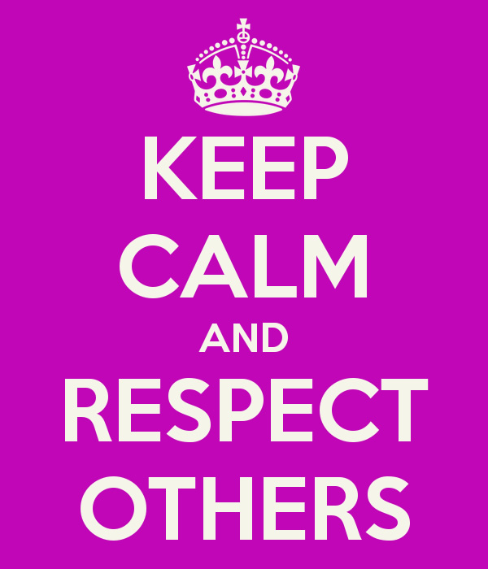
Respect yourself
Respect your peers
Respect your school
Respect your teacher

